1. **Home Page:**
   * A welcoming page with an attractive header showcasing your best bakery items, promotions, and links to other key sections of the site.as you can see in here the theme of homepage and the colour.

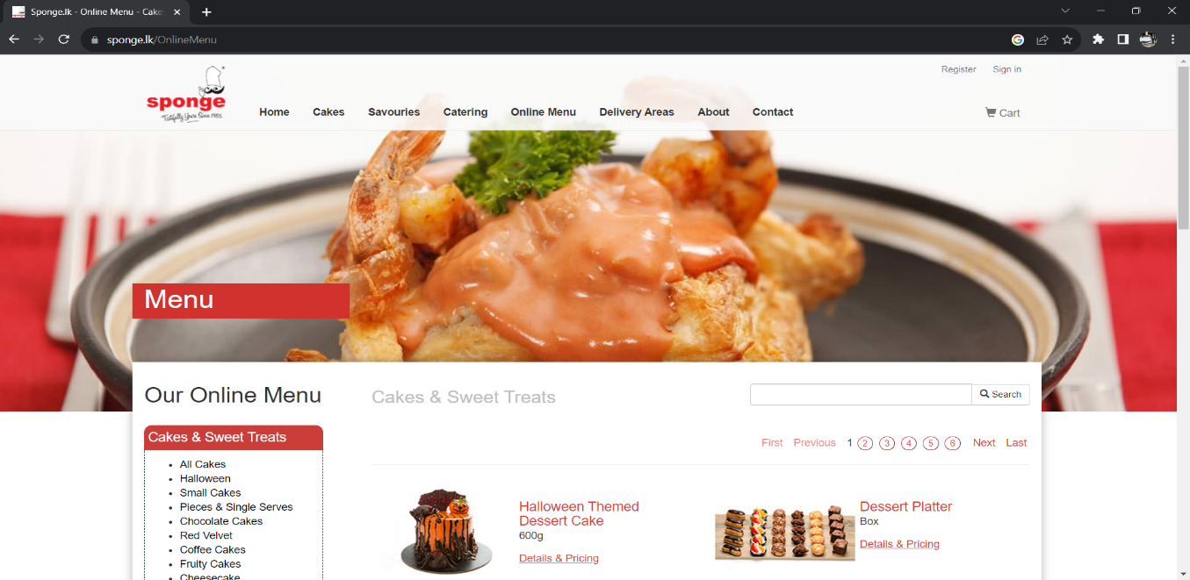

1. **About Us:**
   * Information about the history, values, and mission of your bakery.
2. **Products:**
   * We are going to divide their product into several categories.
     + Cakes: Display various types of cakes, including photos and descriptions.
     + Short eats: Showcase your selection of short eats like pastries, samosas, and more.
     + Breads: Highlight your range of bread products, including traditional Sri Lankan bread.
     + Pastries: Feature pastries and snacks.
     + Seasonal Specials: Highlight seasonal or special products.
   * Each subcategory can have its dedicated page.
3. **Menu:**
   * A detailed menu listing all the bakery items available for customers to choose from.
4. **Order Online:**
   * Provide options for online ordering, including a shopping cart, delivery options, and payment methods.
5. **Gallery:**
   * Display high-quality images of your bakery items, beautifully presented, and organized by category.
6. **Events and Promotions:**
   * Information about upcoming events, promotions, and discounts.
7. **Contact Us:**
   * Contact information, including an address, phone number, email, and a contact form.
8. **Location/Store Locator:**
   * If you have multiple bakery outlets, provide an interactive map or a list of store locations.
9. **Delivery and Shipping Information:**
   * Provide details on delivery options, shipping policies, and areas you serve.
10. **Terms and Conditions:**
    * Legal and business-related terms and conditions for using your website and services.
11. **Privacy Policy:**
    * Explain how you handle customer data and their privacy.
12. **Social Media Links:**
    * Links to your bakery's social media profiles to encourage engagement and following.
13. **Search Functionality:**
    * Include a search bar for users to quickly find specific products or information.
14. **Language and Currency Options (if applicable):**
    * If your bakery caters to a diverse audience, consider offering multiple language and currency options.
15. **Cart page** – shows what the customer has added to his cart.